Gateway User Guide

Gateway has been set up to allow larger pig producers to set up multiple pig movement licences on one spreadsheet in order to save time.

This is a basic user guide aimed at helping those wishing to set up a gateway system for their movements.

In order to set up movements in this way you will need to do the following:

1. Create your spreadsheet using the template sent to you
2. Save the spreadsheet as a CSV file
3. Log onto eAML2 to get your gateway ‘token’
4. Send the email
5. Receive your licences via PDF

The instructions for each of these steps are part of this user guide.

1 - Create Spreadsheet

Complete your spreadsheet template:

Source Site Assurance Number will automatically appear on the licence if it is on the unit’s account. If you enter it manually please enter E in front of the number

This should follow the format:

FarmToFarm

FarmToSlaughter

FarmToMarket

|  |  |  |  |  |
| --- | --- | --- | --- | --- |
| Movement  Type | Source  Herd Mark | Source  Site CPH | Source  Site Postcode | Source Site  Assurance No. |
| *FarmToSlaughter* | *AA1111* | *12/123/1234* | *CV8 2TL* | *E1234* |

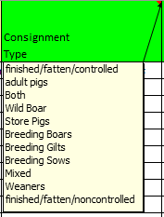

Type of pigs in consignment must match the appropriate format option so that the correct type of pigs shows on the licence

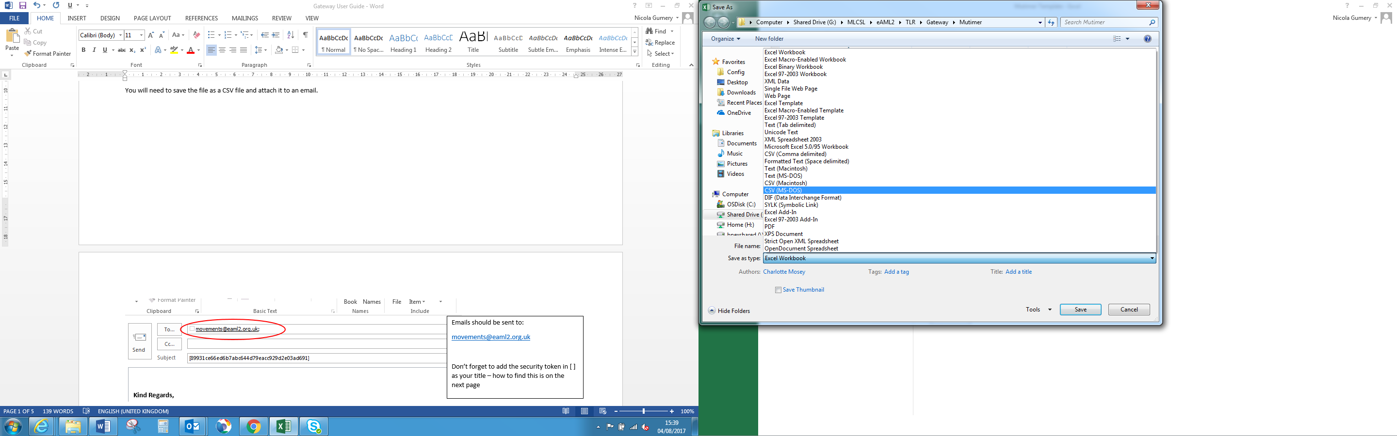2 – Save as a CSV file

You will need to save the file as a CSV file and attach it to an email.

3 - Log into eAML2.org.uk

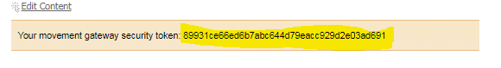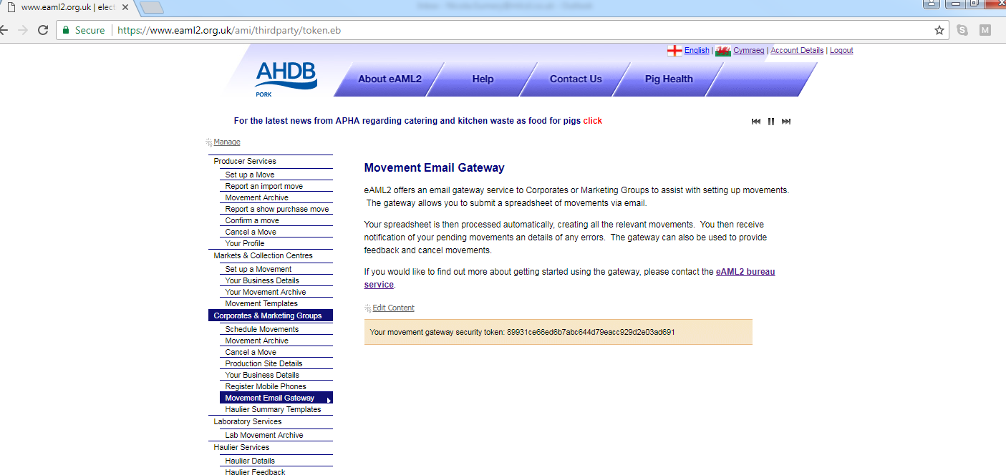

You need to copy the security token displayed to add to your email subject line in square brackets [ ]

Click on ‘Movement Email Gateway’

4 – Send email

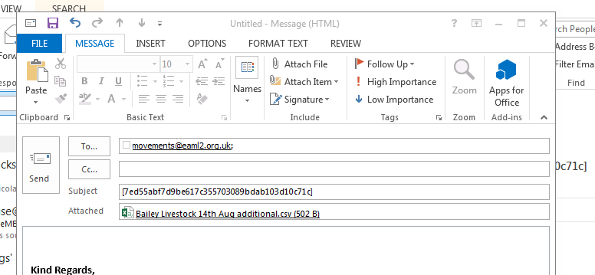

Don’t forget to attach your CSV file

Email the CSV file to

[Movements@eaml2.org.uk](mailto:Movements@eaml2.org.uk)

Don’t forget to add your security token in square brackets [] as the subject

This is an example of the email you will receive from the system once your movements have been submitted.

5 – Revieving your licences via email

This is an example of the email you will receive from the system once you have submitted your movements

The email will have 2 attachments

A summary with any problems encountered while processing your request

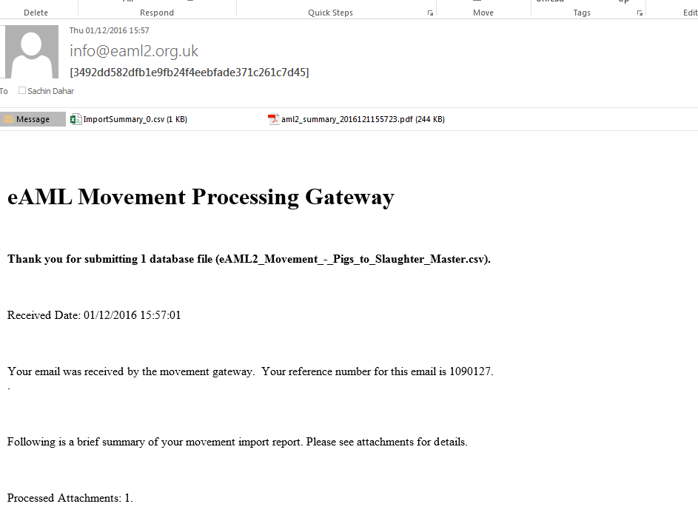

A PDF of your movement licences

Import Summary Notes

ShortCode is the licence reference number – you may wish to copy this into your original spreadsheet for future reference

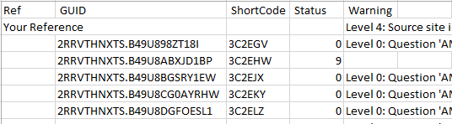

Status Codes

|  |  |  |
| --- | --- | --- |
| Code | Status | Notes |
| 0 | Pending |  |
| 1 | Sent | Sender feedback has been received |
| 3 | Revised | Licence has been amended or revised since receiving feedback |
| 9 | Completed | All feedback has been received |
| 10 | Finished | Movement has been uploaded to AMLS |
| 17 | Cancelled |  |

Warning Codes

The warning codes are errors assigned a severity level from 0 to 4. Level 0 is deemed as information only and will NOT prevent a licence being processed, whereas level 4 warnings will prevent the licence being created and will require correction and resubmission for that movement.

If you send your spreadsheet with headings in row 1 you will ALWAYS get a level 4 error for the first line. This is OK as it is your headings NOT a movement.